**Team name:** codePaws

* + Kenji
  + Massie
  + Maggie

**New Word Game**: Birdle

**Project Description:** Create a game in which a player guesses the right word in 6 guesses or less.

**UserStory:**

As a player I want to guess a hidden four letter word within 6 attemps so that I can challenge my word knowledge and improve my vocabulary.

**Acceptance Criteria:**

* Player can input a 5-letter guess.
* Game informs the player whether each letter in the guess is correct (green), in the word but in the wrong position (yellow), or not in the word (gray).
* Play has up to six attempts to guess the word.
* The game resets after a word is correctly guessed or attempts are exhausted.
* A “Game Over” message if the player runs out of attempts.
* A “Congratulations” message if the word is guessed correctly.
* The modal to display the statistics of the game.

Code Mockup:

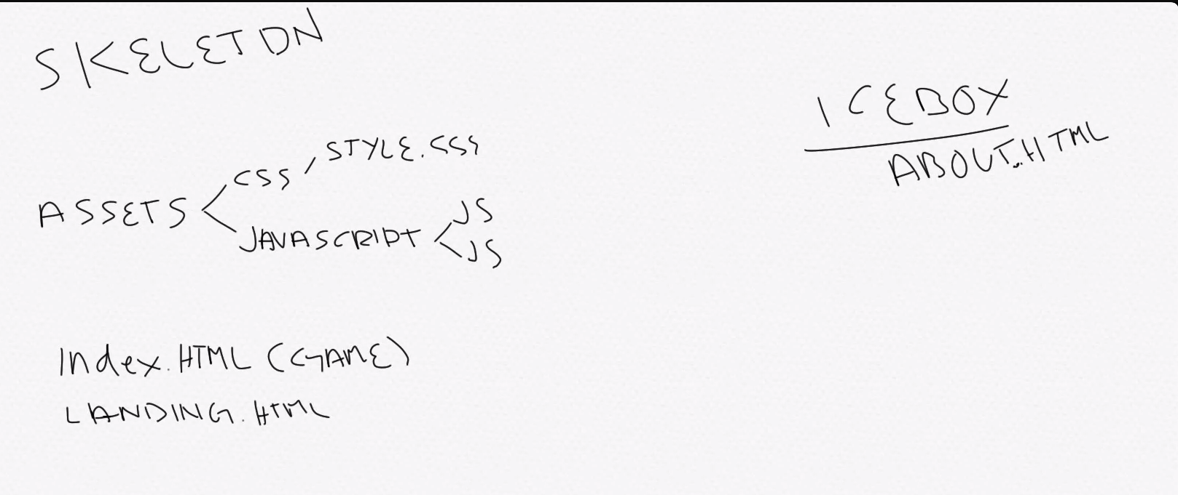

Delegation of development:

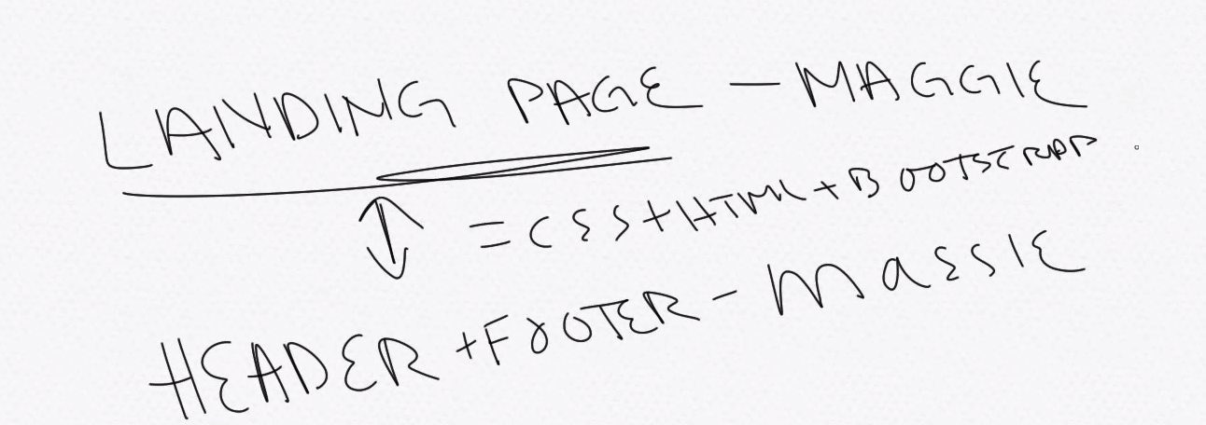

* Maggie- landing page
* Massie- Header/footer
* Kenji – Modal for play button

Wire Frame:

Landing Page: Welcome to Wordle

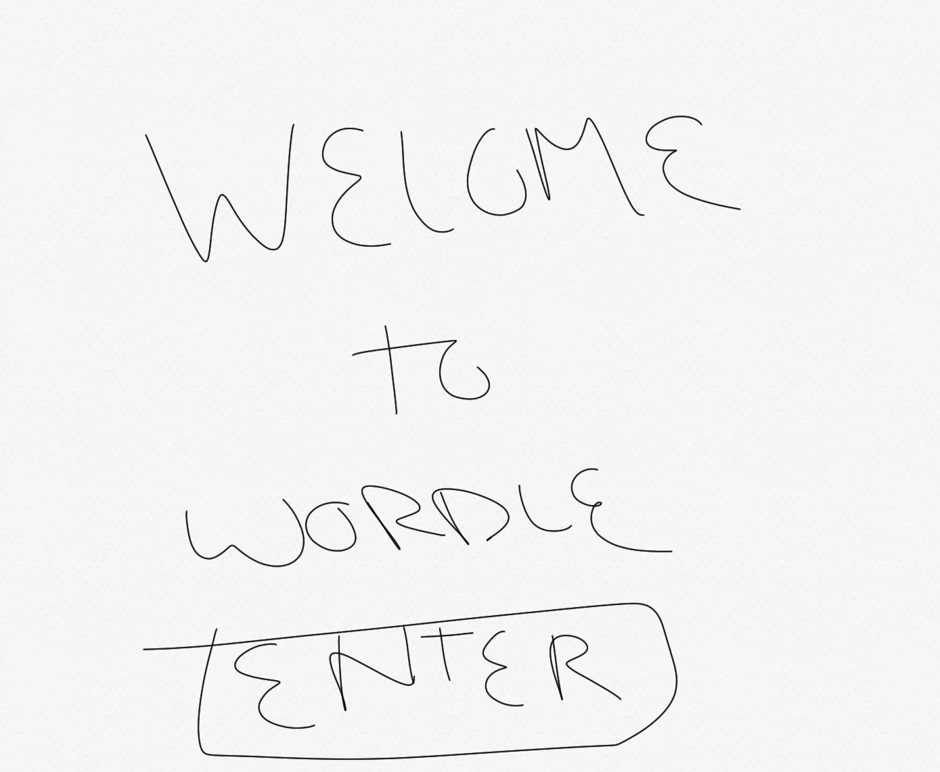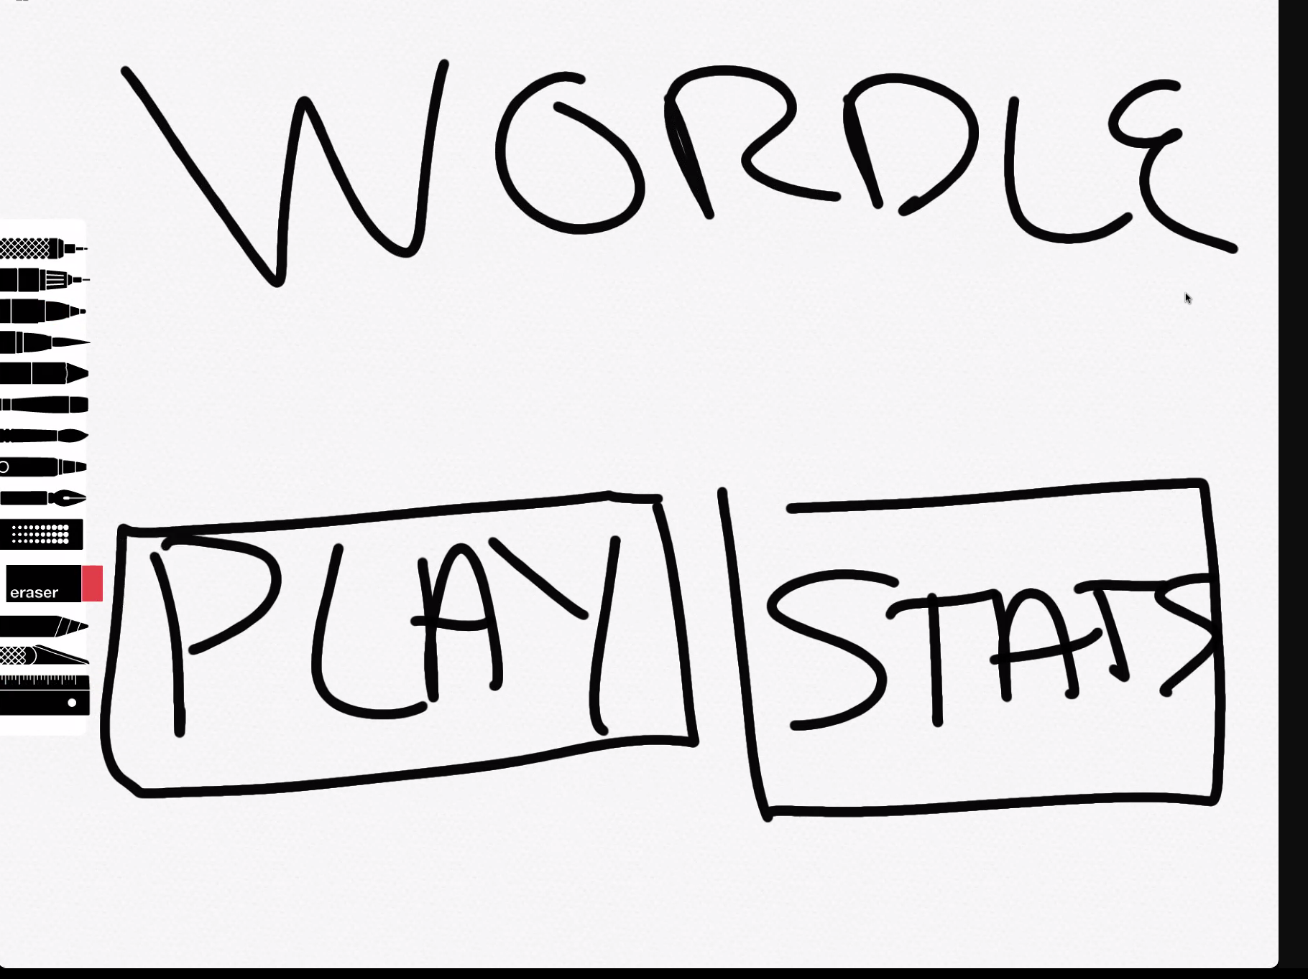

Main Game Page:

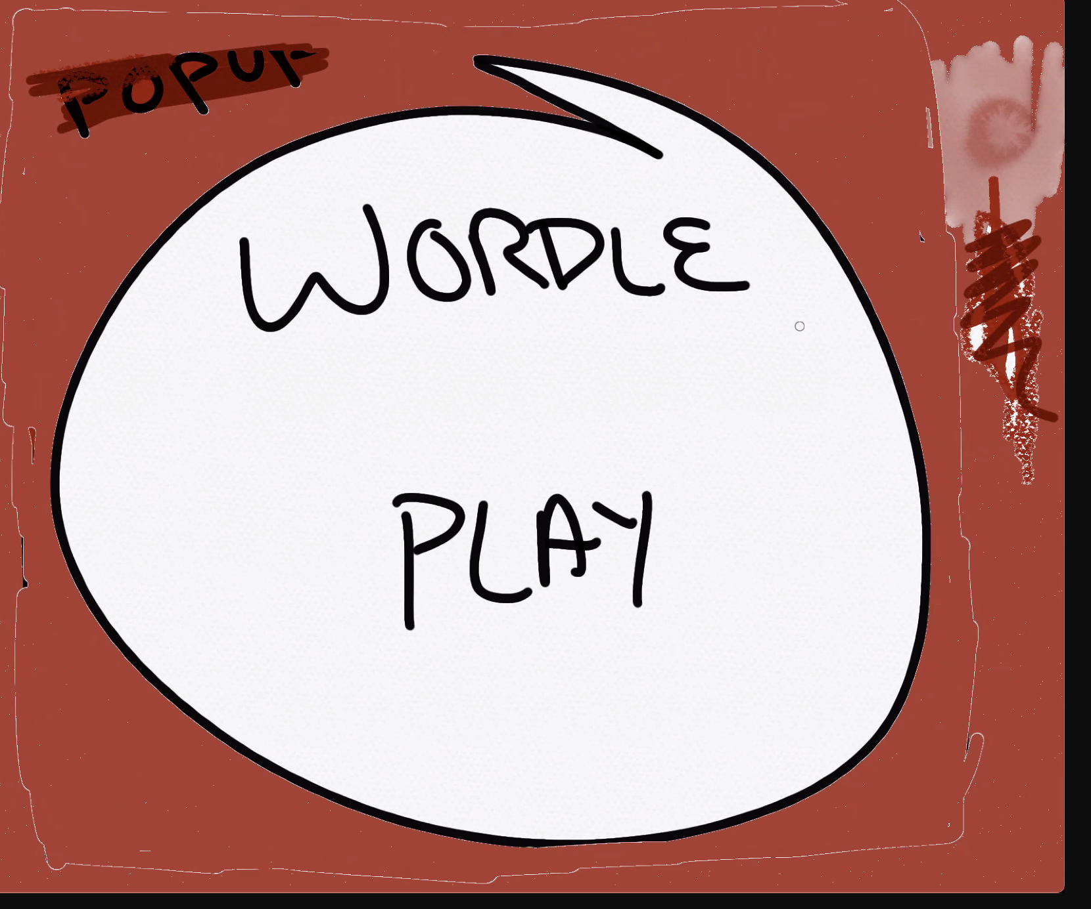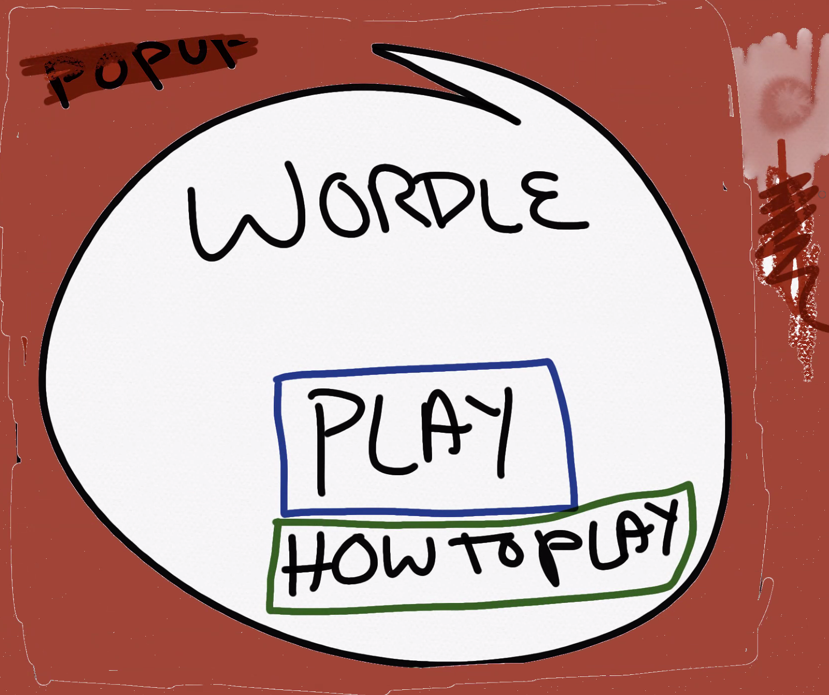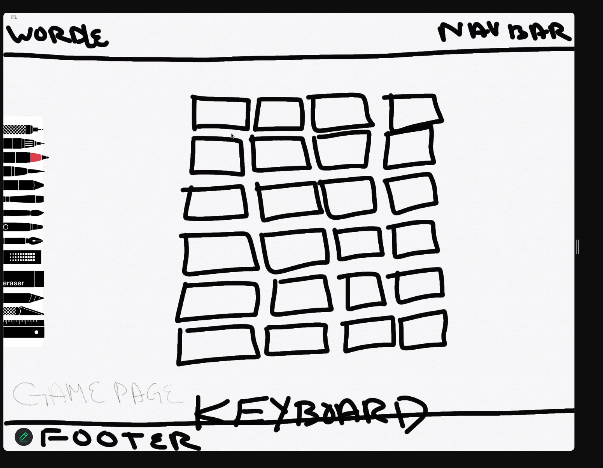

Modals:

-How to page

-Stats page

Define mvp

1. Play a game (with one word) page
2. Landing page (pop up or just a landing page with nav) -first image
   1. How to play (modal popup or html)
   2. Footer ©
3. Add icebox ideas along way
   1. Timer
   2. About us

